**BOSSCHARGER**

**User Manual**

## 

## Product Type: CE-EU/U.S. Standard DC Charger

Material Code: A.81.15.0011

Ver: A00

Contents

[1 Safty Instruction 2](#_Toc29121)

[1.1 Safety Tips 3](#_Toc11330)

[1.2 Instructions for Use of Equipment 4](#_Toc12245)

[1.3 Safety Operation Instructions 4](#_Toc3469)

[2. Product Overview 5](#_Toc30205)

[2.1 Basic Parameters 5](#_Toc18191)

[2.2 Performance Parameters 6](#_Toc18213)

[2.3 Functional Profile 6](#_Toc30132)

[3.Operation Instruction 7](#_Toc899)

[3.1 Charging Instruction 7](#_Toc23502)

[3.2 Charging Operation Interface 7](#_Toc9016)

[3.3 Charging Plug Instruction 8](#_Toc17797)

[4. Troubleshooting 8](#_Toc21198)

[4.1 Error Analysis and possible solutions.](#_Toc13333)

[8](#_Toc13333)

[5. Maintenance 9](#_Toc25921)

[5.1 Maintenance Period 9](#_Toc17293)

[5.2 Heat Disspation System Mauntence Method 9](#_Toc832)

[5.3 Power Distribution System 9](#_Toc15191)

[5.4 Line System 9](#_Toc22701)

[5.5 Circuit Components 10](#_Toc28229)

[5.6 Auxiliary System 10](#_Toc26977)

[5.7 Grounding System 11](#_Toc30289)

[5.8 Apperance 11](#_Toc32483)

[5.9 Emergency Handling 11](#_Toc6264)

[6. Disclaimer 12](#_Toc11656)

[7.Installation Instruction 13](#_Toc5596)

[7.1 Dimension 13](#_Toc16258)

[7.2I nstallation 14](#_Toc20250)

[7.3 Power Cables Connection 16](#_Toc7529)

[8. Power Module Installation 18](#_Toc4908)

# 1 Safety Instruction

## 1.1 Safety Tips

|  |  |
| --- | --- |
| Mark | Meaning |
|  | Please read the operating instructions and notes carefully before starting operation. In order to prevent accidents.  It will be lead to life danger, injury and equipment damage if you are not observe the safety tips, Our company refuses to assume any claim arising therefrom   * **Electrical Hazard**   .   * + Only personnel who have received the training of the charging system and fully mastered the knowledge of the charging system can install the charging system   + For the first time of installation, always observe the safety precautions mentioned in this document and all relevant National Safety Regulations * **Electrical Hazard/ Fire Hazard**   + It is Forbidden that carry out live installation and maintenance work during equipment is with power   + It is Forbidden that use a damaged, worn, or dirty charging plug * **The owner must be careful to run the equipment in a normal condition**   + It is necessary to inspect and maintain the charger regularly   + If the inspection system has security risks, it must be shut off immediately and eliminated.   + The charging reactor maintenance operation shall not be carried out without authorization, only by the manufacturer or authorized agency and units.   + It is forbidden to modify or modify the charging station without authorization   + Please do not remove safety signs, warnings, nameplates, signs or line markings   + No extension cables shall be used when connecting the electric vehicle to the ev power supply device   + Only connect to the electric vehicle or its charging equipment, do not connect to other loads (power tools, etc.).   + Hold the plug when pulling the charging gun. Do not pull the cable.   + Do not bend, squeeze, or roll the charging gun for mechanical damage.   + Never contact with heat sources, dirt or water sources |
|  | * Damage danger * Do not use spray water (garden watering hose, high-pressure cleaning machine, etc.) to clean the charging station. |
|  | * When the charging operation is not performed, the charging gun should be inserted back into the charging gun seat. * If the gun lock fails, please use the emergency unlock |

## 1.2Instructions for Use of Equipment

* + - This type charger is an integrated charger for European standard electric vehicles in both indoor and outdoor areas, and it is strictly prohibited to charge other non-European standard vehicles.
    - The product is high-power high-voltage power equipment, construction and maintenance personnel should with electrician certificate and network access certificate to work.
    - During installation and construction, the relevant construction standards and safety regulations implemented by various regions and countries shall be strictly observed
    - Please properly use and keep the product data documents well.
    - This product is developed, produced, inspected and filed according to relevant safety standards. Therefore, if the instructions and safety technical tips for the specified use are observed, the products will not cause property loss or endanger the health of personnel.
    - The instructions contained in this manual must be strictly followed, otherwise potential safety hazards may occur or cause failure of the safety device. Although this manual explains the relevant safety tips, attention should still be paid to the safety regulations and accident prevention regulations that meet the corresponding application conditions.
    - If user has any problem or error question during usage, please consult the equipment supplier directly . If you seek a third party or non-professional without permission for maintenance, any security consequences caused shall be borne by the user.
    - When you start the first usage, you need to change the user password, and prevent the password leakage.
    - The installation environment of the charging equipment should be far away from the fire sources and other hazard sources.

## 1.3 Safety Operation Instructions

* + - Please read the product instructions carefully before use, and follow the steps in the product instructions strictly
    - It is strictly prohibited for users to conduct improper operations such as dismantling the product without permission, and the adverse consequences caused by improper operation shall be borne by the users themselves.
    - Please do not touch the charging plug or the charging socket of an electric vehicle. Keep the charging plug in a dry state. Do not touch the charging plug with water on your hands.
    - It is strictly prohibited to continue to use the charger when the charging gun cable leaks or the insulation skin is damaged
    - If there is any electricity leakage during product is running, please press the emergency stop button immediately.
    - Make sure that there is no foreign matter left in the charging plug and the charging socket at the vehicle end.
    - It is strictly prohibited to maintain the incoming line under incomplete power failure. When repairing the equipment, the superior switch of the charging reactor must be cut off and the maintenance sign must be hung.

Do not use the emergency stop button in non-emergency situations, otherwise you shall bear the consequences.

# Product Overview

Electric Vehicle charger is a necessary part of large-scale industrialization of New Energy electric Vehicle service infrastructure, in order to adapt to the European countries demands of the development of new energy electric vehicles, accelerate the construction of new energy electric vehicle charging infrastructure, our company developed a new generation independently of European and American standard 60kW, 120kW, 180kW, 240KW series outdoor machine.

By means of flexible power distribution, Charger can control the charging gun for single connector charging or double ,the greatest degree meet the power deployment between the single double gun, reduce the construction cost effectively, this type charger is suitable for bus station, social operation yard and other large charging yard, bring more convenient charging experience for the user.

This product adopts modular design, has multiple protection functions, intelligent automatic power distribution and charging control system, with the characteristics of high conversion efficiency, stable output current and high reliability, and high-power charging of vehicles through the control charging terminal with reliable CAN communication.

## 2.1 Basic Parameters

|  |  |  |  |  |  |  |  |  |  |  |  |  |
| --- | --- | --- | --- | --- | --- | --- | --- | --- | --- | --- | --- | --- |
| Basic Model Parameters | | | | | | | | | | | | |
| **Product Name** | **60KW** | | | **120KW** | | | **180KW** | | | **240KW** | | |
| **Single Gun** | **Both Double Gun** | **Fast-Slow for Double Gun** | **Single Gun** | **Both Double Gun** | **Fast-Slow for Double Gun** | **Single Gun** | **Both Double Gun** | **Fast-Slow for Double Gun** | **Single Gun** | **Both Double Gun** | **Fast-Slow for Double Gun** |
| AC Input Voltage | AC260V~AC485V | | | | | | | | | | | |
| DC Output Voltage | DC 150~1000V | | | | | | | | | | | |
| Constant voltage range (V) | DC 300~1000V | | | | | | | | | | | |
| Power(KW)Output | 60KW | | | 120KW | | | 180KW | | | 240KW | | |
| Max.Output Current | DC 200A | | | DC 400A | | | DC 400A | | | DC 400A | | |
| Max. Output Current for Single Gun | DC 200A | | | DC 200A | | | DC 200A | | | DC 200A | | |
| Number of outgoing port | Single Gun | Double Gun | Double Gun | Single Gun | Double Gun | Double Gun | Single Gun | Double Gun | Double Gun | Single Gun | Double Gun | Double Gun |
| Power distribution mode | Single gun single charge | Both guns are charged | Fast-Slow charged for double gun | Single gun single charge | Both guns are charged | Fast-Slow charged for double gun | Single gun single charge | Both guns are charged | Fast-Slow charged for double gun | Single gun single charge | Both guns are charged | Fast-Slow charged for double gun |
| Degree of Protection | IP54 | | | | | | | | | | | |
| Dimension(W\*D\*H) | 700\*1900\*650mm | | | | | | | | | | | |
| Weight | ≤400Kg | | | | | | | | | | | |

## 2.2 Performance Parameters

|  |  |  |
| --- | --- | --- |
| **Detailed performance parameters** | | |
| **Category** | **Item** | **parameters** |
| AC Input | Input Type | Three Phases Five Wires （A+B+C+N+PE） |
| Input Voltage Range | AC260V~AC485V |
| Input Frequency | 55Hz±10% |
| DC Output | Stable pressure accuracy | ≤±0.5% |
| Stable Current accuracy | ≤±1% |
| Output voltage ripple | Peak coefficient≤1% |
| Performance&Function | Power Factor | ≥0.99 |
| Efficiency | ≥95% |
| Standby power consumption | ≤0.1% output rating |
| Equal Current imbalance | ≤±5% |
| Protection | Input/output over/under voltage protection;Over current and short circuit protection;Over temperature protection;lightning protection |
| Environmental conditions | Working Temperature | -40℃～+70℃，Derating above 50℃ |
| Humidity | 5%～95%（non-condensing） |
| Altitude | ≤2000,Derating above 2000m |

## 2.3 Function Profile

1. By using of the charging mode of single gun or two guns, according to the actual charging demand sent by the vehicle BMS, the switching power can achieve the purpose of the high power fast charging and the average power of two guns.
2. Modular design, multiple modules work in parallel, a single module error won’t affect the use of the whole machine.
3. Support multi-channel output, according to the number of parking Spaces, the charger can select the number of output Spaces flexibly , generally, meet the demand of charging stations.
4. The charger exchanges data with the vehicle through CAN bus to achieve the purpose of intelligent charging.
5. The charger uses 12.1-inch LCD touch screen, display bright color, can realize the display of outdoor high brightness environment, normal use in high and low temperature environment, convenient for users to operate.
6. The BMS power supply has three modes of 12V, 24V or 12V / 24V dual power switching, which can adapt to the charging requirements of different types of vehicles.
7. It has local Ethernet, communication interface, 4G wireless communication and real-time communication with the background monitoring platform, report the operation status of the equipment in time, and ensure that the monitoring
8. The charging system has remote and local upgrade functions, and the software can be upgraded remotely when needed.

# 3. Operation Instruction

## 3.1 Charging Instruction

1. Make sure that the charger system is in a normal state before charging.
2. Before charging, ensure that the charging gun line is not damaged, and the charging gun head is not flooded. If the gun head is flooded, do not charge directly.
3. Before charging, users should read the user manual fully, and be familiar with the safe operation instructions to prevent dangerous operation.
4. Before charging, the user should be familiar with the charging operation steps to prevent improper operation.

## 3.2 Charging Operation Interface

|  |  |
| --- | --- |
| a、Charging machine standby  微信图片_202303272223571 | b、Swipe the card and select the charging type  微信图片_20230327222357 |
| c、State in charging  微信图片_202303272223572 | d、Swipe your card and stop charging  微信图片_20230327222620 |

## 3.3 Charging Plug Instruction

* + 1. Check whether the charging socket at the car end is normal, whether there is foreign matter or dust in the socket or socket, if yes, please clean it up
    2. Clean is allowed only if the charging gun is not connected to the vehicle.
    3. Clean the charging gun wires and dirty contacts with a dry cloth.It is prohibit to us corrosive detergent, water spray, or steam spray cleaner.
    4. Do not immerse the head of the charging gun in the liquid.

# Troubleshooting

4.1 Error Analysis and possible solutions.

|  |  |  |
| --- | --- | --- |
| Item | Name of the alarm or Error | Solution |
| 1 | Arrester Error | Check the status of the lightning protection device, if the lightning protection device can show a red window, it means damage, please replace. |
| 2 | Emergency push-button Error | Please check whether the product is not stopped immediately. If the error has been solved, please pull up Emergency Stop button, and cover the emergency stop protection cover. |
| 3 | The DC output contactor adhesion Error | 1. Supply power to the contactor directly, measure whether the contactor closing and feedback nodes are normal. 2. When the DC contactor is closed, the DC control dry contact is closed and the detection signal of the plate is normal. |
| 4 | Bridge contactor adhesion Error | 1. Supply power to the contactor directly, measure whether the contactor closing and feedback nodes are normal. 2. When the DC contactor is closed, the DC control dry contact is closed and the detection signal of the plate is normal. |
| 5 | Charger access control Error | Please check whether the cabinet door of this product is completely closed; confirm that the door is closed but still displayed Police, please check the status of the micro-switch, if damaged, please replace. |
| 6 | Charger overtemperature Error | 1. 。Please check whether the system air duct is blocked and whether the dust filter has too much ash. 2. Please check whether the fan outlet of the charger works normally. If the fan error, please replace the fan. |
| 7 | AC input contactor rejection | 1. Whether the AC contactor is damaged (the closure cannot be closed properly, and the feedback node is wrong) 2. The control dry contact and the feedback dry contact on the monitoring board are abnormal. |



**Warning： In order to prevent personal electric shock accidents, the front-end power supply of the equipment shall be cut off during fault detection and treatment, and protective measures shall be taken, otherwise the equipment shall be responsible for the consequences.**

# Maintenance

## 5.1 Maintenance Period

|  |  |  |  |  |  |
| --- | --- | --- | --- | --- | --- |
| **Item** | **Maintenance Period** | **Solution** | **Item** | **Maintenance Period** | **Solution** |
| Electric Fan | Weekly | Overhaul | Display screen inspection | Weekly | Overhaul |
| Dust cotton | Monthly | Clean | Secondary line inspection | Weekly | Fastening |
| Dust cotton | Weekly | Clean maintenance | Switch protection | Weekly | Overhaul |
| Module communication | Weekly | Overhaul | Emergency stop function inspection | Weekly | Test |

## 5.2 Heat dissipation system maintenance method

In order to avoid dust and willow catkins blocking the dust filter, it is recommended to clean the dust filter at least once a month, and the specific cleaning time can be determined according to the site environment. The cleaning method is as follows

* + 1. With a vacuum cleaner to the dust net, will be attached to the dust net dust, catkins for cleaning. If the willow catkins cannot be removed from the cabinet, the dust filter should be removed from the cabinet, and then clean up with a vacuum cleaner.
    2. After cleaning, check whether there are gaps around the dust cotton. If there is a gap, the dust net should be reinstalled again. Press it through the pressure strip to avoid a large amount of dust and catkins entering the cabinet.

## 5.3 Distribution system

The Steps of Power on/off of Distribution Box

1、 Check whether the power supply voltage is normal

2、Close: firstly, close the main switch of the distribution box, and then close the branch loop switch in turn.

1. Pull the switch: firstly, pull each branch loop switch, and then pull the distribution box main switch.

## 5.4 Line System

1、Wire Trunking

* + - Weekly routine inspection: check whether the wire groove is fixed, whether the cover plate is complete, and whether the wire in the groove is exposed
    - Monthly routine inspection: check whether the wire groove is firmly fixed, whether the cover plate is complete and tight, and whether there is any subsidence and deformation phenomenon.
    - Annual routine inspection: check whether the wire groove is fixed firmly, whether the cover plate is complete and tight; whether the joints are loose, whether the distortion and deformation phenomenon, whether the fasteners are loose, corrosion and rust phenomenon.

2、 Cable

* + - Weekly routine inspection: check whether the cable is hot and damaged.
    - check whether the cable is hot and damaged, whether the cable is stressed by the external tension, and whether the fixation is firm
    - Annual routine inspection: check whether the connection between the cable and the switch is close, whether the grounding is reliable, whether the cable is hot or damaged, whether the insulation resistance of the cable meets the provisions, whether the sealing measures of the cable into the box are intact, and whether the hole sealing is tight.

## 5.5 Circuit components

* + - Weekly routine check: whether the emergency stop button is working normally; after the emergency stop is pressed, confirm the control circuit is disconnected; whether all operation indicators are working normally; whether the charging gun fixed buckle is damaged and whether the connection is abnormal.
    - Quarterly routine inspection: whether the circuit components are fixed firmly, whether there is a fire burning phenomenon at the connection of the components, found abnormal, replace the parts in time.
    - Annual routine inspection: use a brush and a vacuum cleaner to remove the dust on the box, and do not blow the dust into the components when cleaning, resulting in a short circuit. Check all the components of the box comprehensively, and replace the abnormal parts in time.

## 5.6 Auxiliary System

Indicator Light

* + - Monthly routine inspection: check whether the indicator lamp is burned out and whether the fixation is firm.

Annual routine inspection: whether the connection between the wire and the indicator is fastened, the indicator has no corrosion phenomenon. Whether the accessories of the indicator lamp are complete and intact, whether the fixation is firm, whether it is burned out, and whether the insulation of the incoming line meets the regulations.

## 5.7 Electrical grounding system

Electrical grounding is very important in electrical operation. The safety of people and equipment mostly depends on the integrity and safety of the grounding equipment. If the grounding equipment is not strong, unreliable, does not meet the requirements of the specification, will inevitably cause safety risks, there is the possibility of personal crisis and equipment safety. Therefore, it must be carefully inspected and timely maintained, so that the grounding system is always maintained in a safe state.

* + - Weekly routine inspection: check whether the grounding of the equipment is loose, loose or changed. Carefully observe whether the equipment grounding is intact, whether the anti-loosening device is complete, and whether it has been damaged or removed.
    - Monthly routine inspection: whether the compression joint of the electrical grounding system is corroded, oxidized and causes poor contact, resulting in the increase of the grounding resistance phenomenon. Whether the grounding mark is complete and obvious, and whether there is no loss or damage phenomenon.

 Annual routine inspection: the grounding of electrical equipment should be checked every year to check whether the grounding wire and grounding terminal are in good condition. Use a multimeter to test whether the grounding resistance exceeds the standard and whether it meets the grounding requirements.

## 5.8 Appearance

Monthly routine inspection, whether the appearance of the cabinet is stains, the overall cleaning of the cabinet, whether the sheet metal of the cabinet is deformed and rusted, whether the paint is damaged, timely paint repair and antirust treatment to modify the appearance.

## 5.9 Emergency Handling

In order to maintain the DC power supply of the split charger system, some emergency measures are needed to treat the faults threatening the DC power supply.

The possible faults in the power system mainly include: AC distribution circuit unrecoverable damage, DC load or Short circuit in DC power distribution, monitoring module damage, DC output overvoltage, module blockade, etc.

1、 AC power distribution emergency treatment

When the AC power distribution fault causes the interruption of the module AC power supply, the AC mains can be directly introduced into the input switch of the charging module.

2、Disaster accident

Disaster accidents include charging equipment failure caused by lightning strike, water flooding, earthquake, fire and other disasters. Prevention should be given to disasters that may seriously affect safety. At the same time, the charging station should have countermeasures to deal with these disasters and corresponding manpower and material resources, and should have emergency management regulations and emergency repair regulations for major accidents.

# 6.Disclaimer

Product damages, failures or defects caused by the following reasons are not responsible for free repairs:

* Beyond the scope of the warranty period;
* Failure to install in accordance with the requirements of the user manual, or improper operation or failure to comply with relevant local standards, resulting in product damage or failure;
* Damage to the equipment casing during transportation and handling;
* Natural wear or electrochemical corrosion caused by equipment operation;
* Changing the original design of the product without authorization, resulting in product damage or failure; intentional or negligent product damage or failure;
* Product damage or failure due to force majeure (lightning strikes, bad weather, natural disasters, etc.);
* Product damage or failure due to failure to comply with Party B's user manual;
* Any product serial number has been altered, altered or damaged;
* Product damage or failure caused by improper mobile device location;
* After receiving the contract equipment, the customer shall ensure that it is placed reasonably, safely, and without damage, and that the location, environment, temperature, etc. meet the installation and storage conditions of the contract equipment. Return to factory for aging detection;
* Poor heat dissipation of equipment caused by customer reasons (such as customer design cabinet problems, improper installation location, failure to remove dust in time, etc.), equipment damage is not within the scope of our warranty;
* For charging or metering problems caused by the customer's background system, the customer should contact the manufacturer to deal with it.

# 

# Installation Notes

## 7.1 Equipment Dimensions

1、Charger Size：700mm（W）x 650mm（D）x 1900mm（H）

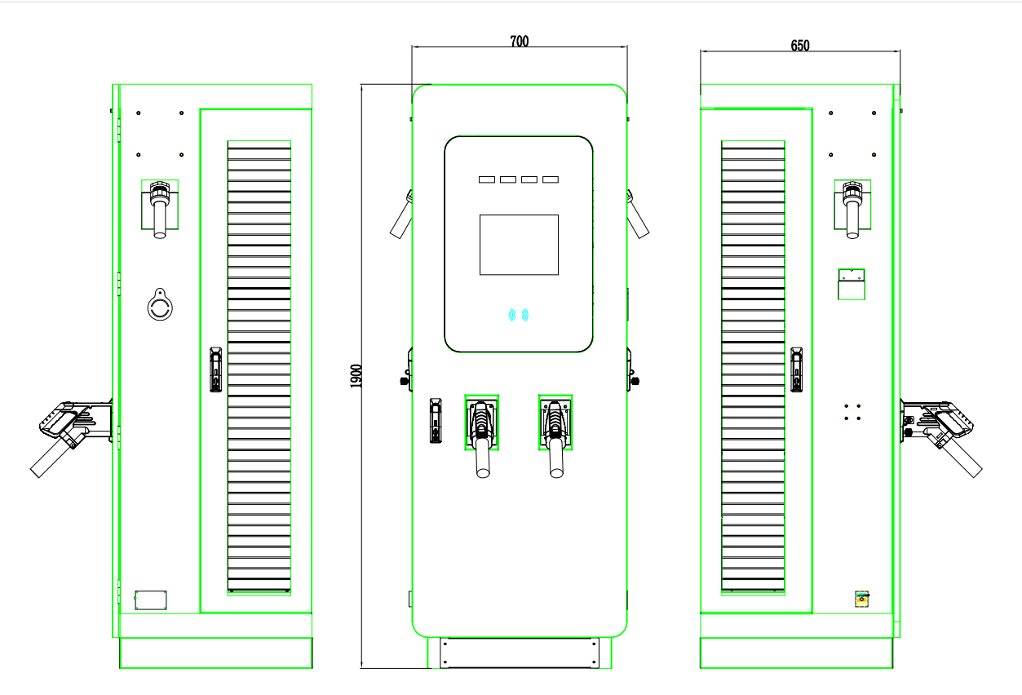

2、Hole size of charger base

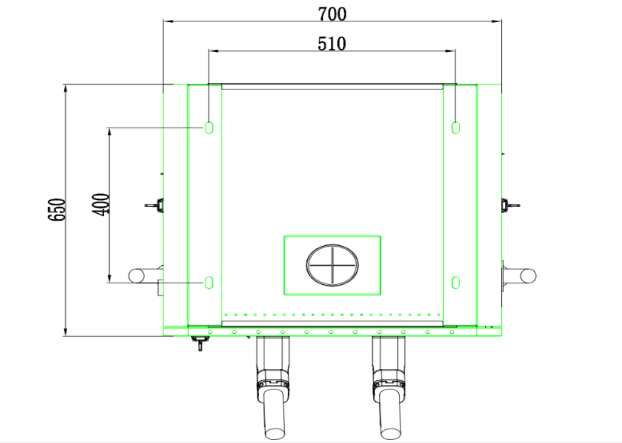

## 7.2 Equipment Installation

#### 7.2.1 Charger Installation Requirements

1. The charger has a front door and a left and right door, and an operating space needs to be reserved around it. See Figure 7.2.1-A below for the reserved dimensions;
2. Cabinet recommended to be installed on the basis of concrete or groove steel;
3. pre-bury the cable in advance, the cable reserved length is detailed in Figure 7.2.1-B below;
4. installation base height recommended 200mm (too high not easy to operate and maintain), installation vertical inclination not more than 5%;
5. mounting surface pre-buried 4 M12 stainless steel bolts, bolt thread exposed ground 30 ± 3mm or mounting surface pre-buried 4 M12 (GB/T 22795- 2008) casing reinforced expansion bolt;

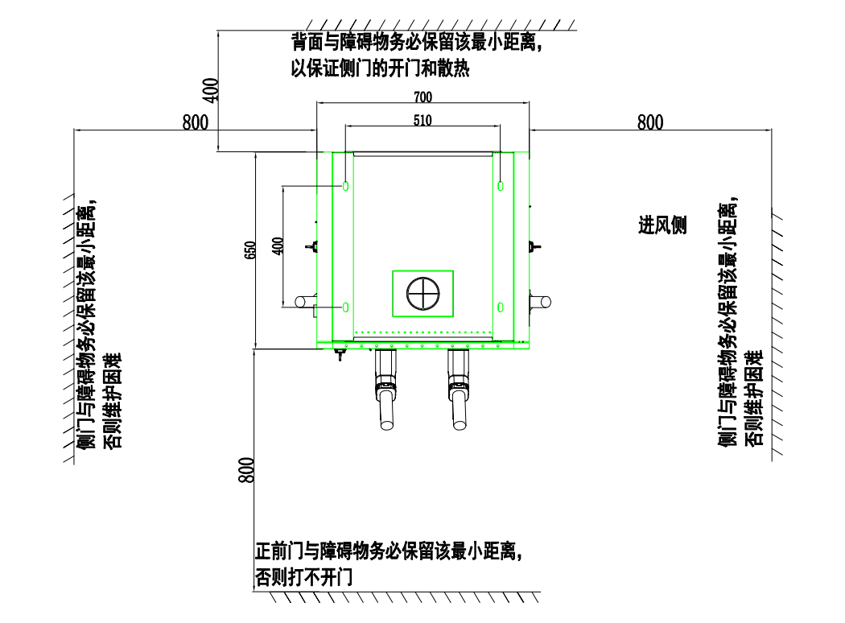

Figure 7.2.1-A Charger Placement Requirements

Keep the minimum distance between the back and the obstacle to ensure the opening and cooling of the side door）

（The minimum distance between the side door and obstacles must be kept, otherwise maintenance will be difficult）

（The minimum distance between the front door and obstacles must be kept, otherwise the door cannot be opened）

（The minimum distance between the side door and obstacles must be kept, otherwise maintenance will be difficult）

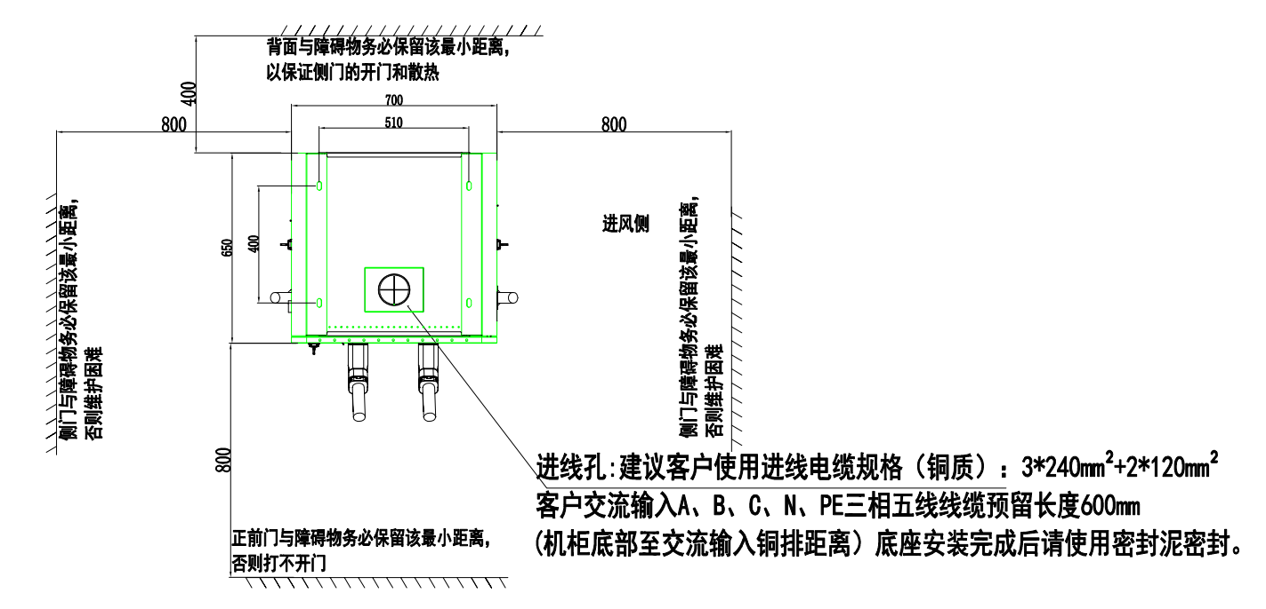

Figure 7.2.1-B Requirements for reserved length of input cable

Inlet hole: It is recommended that customers use the incoming cable Specifications (copper): 3\*240mm²+2\*120mm²

Customer AC input A, B, C, N, PE three-phase five-wire cable reserved length

600mm

(The distance from the bottom of the cabinet to the AC input copper bar) After the base is installed, use sealing mud to seal it.

#### 7.2.2Charging Equipment Installation Steps

1. Prepare the corresponding tools

Drill 4 holes with a diameter of 16mm and a depth of about 100mm on the cement base, and then insert the expansion bolts through the expansion part of the wall into the drilled holes

(If the bolts have been pre-embedded on the installation foundation surface in advance, this step is ignored)

1. Remove the outer packaging
2. Align the holes of the device, place it on the cement base, and lock it tightly with M12 nuts (elastic flat washers)
3. Connect the power distribution cable, see Figure 7.2.2-A below for details
4. Seal the cable inlet hole with sealing mud, see Figure 7.2.2-A below for details

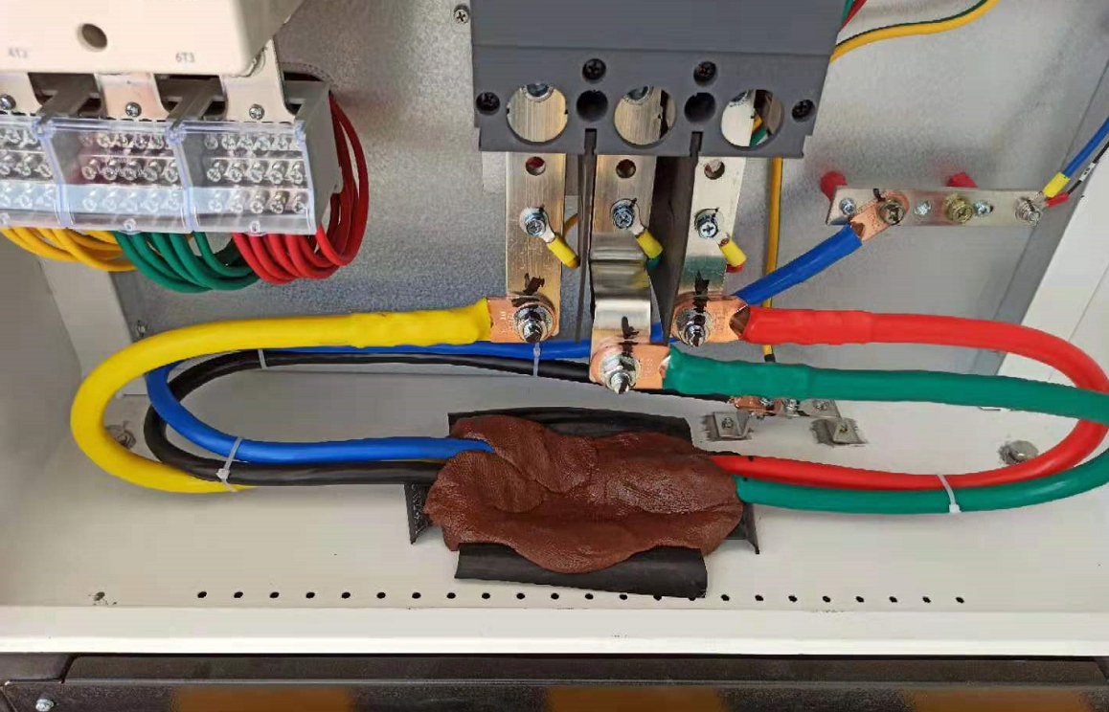

Figure 7.2.2-A Requirements for access cables and sealing mud

## 7.3 Construction of distribution cables

#### Distribution cable layout requirements

1. The input power line of the system is introduced from the bottom of the charger, the power cable should be laid through the cable channel.
2. The charger AC power supply should be used as the main power supply, AC power supply system adopts three-phase five-wire system.
3. AC power line should adopt copper core wire, power line sectional area should be appropriate with the load.
4. Outdoor power line according to the power specification laid, power line routing must be separate from the signal line.
5. Outdoor power line according to the power specification laid, power line routing must be separate from the signal line.
6. Outdoor power line according to the power specification laid, power line routing must be separate from the signal line.
7. Power Lines are not allowed to have broken heads, damage, scuffing

#### AC input cable specifications recommended (Copper wires)

|  |  |  |  |
| --- | --- | --- | --- |
| Capacity（kW） | Cable specification（ mm²） | Screw Specifications(Diameter: mm) | Terminal Type |
| 60kW | 3\*35mm²+2\*16mm² | A\B\C Use M8，  N\PE Use M6 | Must fit cables and screws |
| 120kW | 3\*95mm²+2\*35mm² | A\B\C Use M10，  N\PE Use M8 | Must fit cables and screws |
| 180kW | 3\*185mm²+2\*95mm² | A\B\C Use M16，  N\PE Use M10 | Must fit cables and screws |
| 240kW | 3\*240mm²+2\*120mm² | A\B\C Use M16，  N\PE Use M12 | Must fit cables and screws |

#### Post-installation inspection

1. Sealing

According to the design and protection level requirements, the bottom of the cabinet and the base of the junction must be sealed with fire-proof mud to prevent insects or dirt from entering the cabinet.

1. Stability

After the installation of the charger, from different directions to shake the cabinet, should not feel obvious loosening and shaking.

1. Cleanup
   * + All transport and packaging materials are properly handled in accordance with local regulations.
     + Clean the cabinet and surrounding debris, such as small cables, straps, screws/mother, etc., do not leave behind installation tools on site or charger in vivo (to record the type and quantity of tools in case of omission).
     + Use an anti-static cloth to wipe out the insulation, do not use any corrosive solvents.
2. Inspection
   * + Check if the base is secured and sealed.
     + heck that the internal device is secure and reliable.
     + Check that electrical connections and wiring are correct and complete, that connections are secure, and that grounding is reliable.
     + Check if the equipment protection level meets the requirements, especially at the bottom of the charger cable inlet.
     + Check if the equipment protection level meets the requirements, especially at the bottom of the charger cable inlet.
     + Check the equipment installation comprehensively according to the basic installation drawing.

# 

# 8.Module address setting

|  |  |  |  |  |  |  |  |
| --- | --- | --- | --- | --- | --- | --- | --- |
| 60KW Single Gun | 60KW Double Gun | 120KW Single Gun | 120KW Double Gun | 180KW Single Gun | 180KW Double Gun | 240KW Single Gun | 240KW Double Gun |
|  |  |  |  |  |  |  |  |
|  |  |  |  |  |  | M8（G0 A8） | M8（G2 A8） |
|  |  |  |  | M6（G0 A6） | M6（G2 A6） | M7（G0 A7） | M7（G2 A7） |
|  |  | M4（G0 A4） | M4（G2 A4） | M5（G0 A5） | M5（G2 A5） | M6（G0 A6） | M6（G2 A6） |
| M2（G0 A2） | M2（G2 A2） | M3（G0 A3） | M3（G2 A3） | M4（G0 A4） | M4（G2 A4） | M5（G0 A5） | M5（G2 A5） |
|  |  |  |  |  |  |  |  |
|  |  |  |  |  |  | M4（G0 A4） | M4（G1 A4） |
|  |  |  |  | M3（G0 A3） | M3（G1 A3） | M3（G0 A3） | M3（G1 A3） |
|  |  | M2（G0 A2） | M2（G1 A2） | M2（G0 A2） | M2（G1 A2） | M2（G0 A2） | M2（G1 A2） |
| M1（G0 A1） | M1（G1 A1） | M1（G0 A1） | M1（G1 A1） | M1（G0 A1） | M1（G1 A1） | M1（G0 A1） | M1（G1 A1） |
| Note: G is the module group number; A is the module address. Set the module address in order from bottom to top. | | | | | | | |